**Tiling Assembly for Annotation-independent Novel Gene Discovery**

By Jennifer Lopez and Kenneth Watanabe

Last edited on September 7, 2015 by Kenneth Watanabe

The following procedure explains how to run the Tiling Assembly (TA) on RNA-seq data to identify genes of an organism.

**Short read alignment**

Before TA can be run, the short read the RNA-seq short read data must be aligned to the genome. The following examples will demonstrate how to align the data using the Tophat alignment software. To run Tophat, enter the following command at the LINUX prompt:

$ tophat –o <tophat_dir> -I 50000 –p 6 <index_file> <fastq_file1>,<fastq_file2>,<fastq_file3>

where <tophat_dir> is the output directory, -I 50000 specifies a maximum intron length of 50,000bp, index_file is the indexed genome file generated by bowtie2build, and fastq_filex are the FASTQ RNA-seq files.

Tophat will generate a file called junctions.bed. This is a human-readable text file that contains the junction information identified from the short read data. This data will be used to identify introns.

Tophat will also generate an alignment file called accepted_hits.bam. This file is in a non-human-readable format and cannot be used by the Tiling Algorithm in its current form. The data needs to be converted to a sam file and loaded into a database table.

To convert a bam file to a human readable sam file, we use the samtools software. To convert the accepted_hits.bam file to a sam file use the following command:

$ samtools view accepted_hits.bam > accepted_hits.sam

A database table must be created in MySQL to store the short read data. The table can be created either by using MySQL commands or by Navicat. Below is a description to create tables via MySQL. To create tables using Navicat, please refer to the Navicat documentation.

**Creating database tables via MySQL:**

Next, the data needs to be stored into a database table so that TA can rapidly scan through the data. Log onto your server and enter the following command

$ mysql –u <mysql_user_name> –p  
Enter password: <password>

Connect to the database that you wish to store the data by entering the following command at the MySQL prompt:

MySQL> connect <database>;

To create a short read table, use the “CREATE TABLE” command as described in the appendix of this document.

If you already have a short read table and wish to create a new table using the existing table as a template, you can enter the following command:

MySQL> create table short_reads_test6_sam like short_reads_sam;

The above example will create a table called “short_reads_test6_sam” that has the same column definitions as short_reads_sam. The actual data in short_reads_sam table will NOT be copied to short_reads_sam1.

A MySQL interface program such as Navicat can also be used to create the database table.

Next the junctions and junction_ends tables must be created to store the junction information in the junctions.bed file. MySQL commands can be used to create the tables similar to how the short reads table was created. Examples of the commands used to create these tables in the appendix of this document.

If you already have a junctions and junction_ends table, you can make a copy of the tables using these tables as a template. The following commands show how to create the tables junctions1 and junction_ends1 using the junctions and junction_ends tables as templates.

mysql> create table junctions1 like junctions;

mysql> create table junction_ends1 like junction_ends;

**Loading the data into the MySQL database**

Create a subdirectory under your home directory called “perl”. Transfer all PERL scripts into this directory. It is necessary that all the TA software resides in the same directory. Before running the TA software, you must edit the connDB.pl script and enter the username and password of a valid MySQL account that has access to the short_read table created in the previous section.

The first module of the TA software is the “load_sam_file.pl” script. This script loads the sam file into a selected table. Below is a screen shot of the load_sam_file script. When running the load_sam_file.pl script, the following window will appear. Enter the sam file into the “File name” prompt. Enter the database name and table name to store the sam file. The “Sample Type” and “Sample Name” fields were added so that multiple sam files can be loaded into the same table and the data can be distinguished. E.g. Sample Type: Control; Sample Name: Replicate1.

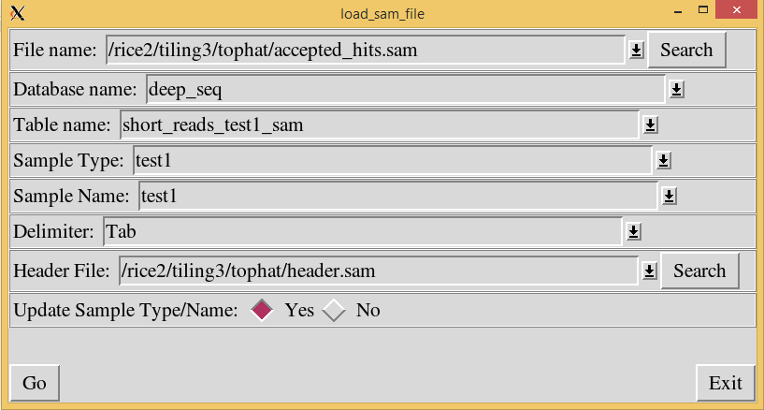

The header file is a file with the field names. This file tells the load_sam_file.pl script the field names in the database. A default header.sam file is included with the TA software.

The junctions.bed file created by Tophat must now be loaded into the junctions and junction_ends tables. To do this, run the“load_junctions.pl” script. In the “File name” prompt, enter the junctions.bed file.

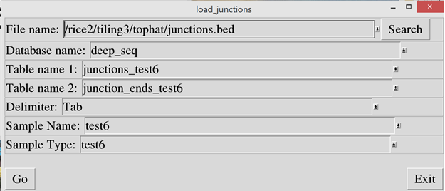

**Running the Tiling Assembly software**

Then the “exon_builder2.pl” script must be run to scan the short read data and identify the exons based on the overlapping reads. In the “Output File” prompt, enter the name of the output file. Since some of the reads mapped across junctions, these reads will be saved into a separate output file. Enter the output file for these reads into the “File for reads with introns” prompt. In the “Short read table”, enter the same table name used in the load_sam_file script.

Note: An organism must be specified so that the Tiling Assembly can determine the number of chromosomes and their names.

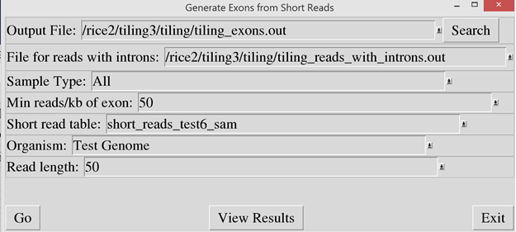

Then run “exons_from_junctions.pl” script to identify short exons from the junction data. In the “Input File” prompt, enter the output filename that was used in the exon_builder2 script. In the “Output File” prompt, enter a file name to store the resulting exon data.

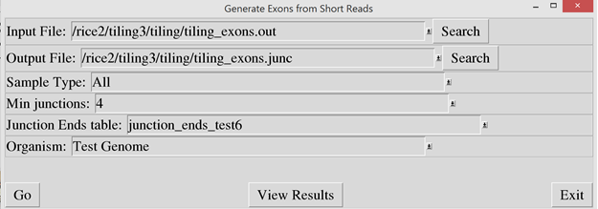

Then run the “link_exons.pl” script to link exons together that are closely spaced. If two exons are closer than the specified threshold, they are combined into a single exon. In the “Input Exon File”, enter the output file name from the exons_from_junctions script. In the “Output File” prompt, enter a file name to store the resulting exon data.

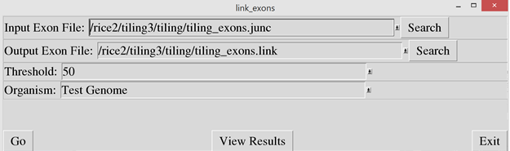

Then run “scan_exons.pl” script to identify exons that have been mistakenly linked together due to noise or via the link_exons script. If a junction is identified within an exon and the reads aligned on the intron are less than the intron threshold, compared to the adjacent regions, it is considered an intron and the exon is split. If not, the junction is ignored. In the “Input Exon File”, enter the output file name from the link_exons script. In the “Output File” prompt, enter a file name to store the resulting exon data.

This step may take a long time depending on the number of records in the short read table.

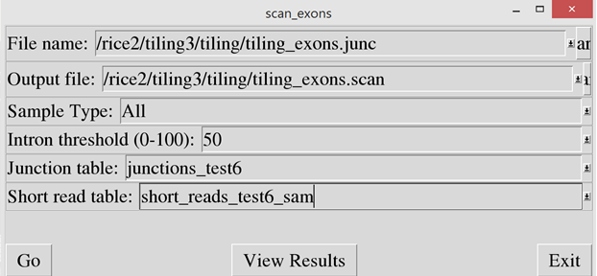

Then run “transcript builder2.pl” script to assemble the exons into transcripts based on the junction alignment. In the “Input File” prompt, enter the output file used in the scan_exons script. In the “Transcript File” and “Exon File” prompts, enter the file names to store the transcript and exon data. The output files will be in bed format. In the “Minimum gene footprint” prompt, enter the minimum footprint (in nucleotides) necessary for consideration as a gene. Any identified gene with a footprint less than this value will be disregarded. All gene names will be prefixed by the value entered in the “Gene Name Prefix” field. In the “Organism” field, enter the organism name from the pull-down so that the program will know the name and number of chromosomes.

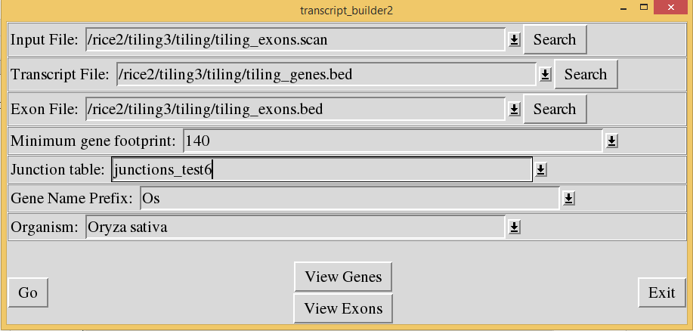

The “Transcript File” and “Exon File” are the final results of the Tiling Algorithm. These files can be loaded into a genome browser such as the UCSC Genome Browser for viewing.

**Appendix**

To create a table to store the short read data, enter the following command after logging into MySQL. This will create a table called short_reads_sam.

CREATE TABLE `short_reads_sam` (

`read_id` varchar(40) NOT NULL DEFAULT '',

`flag` varchar(10) DEFAULT NULL,

`chromosome` varchar(5) NOT NULL DEFAULT '',

`start_position` int(11) NOT NULL DEFAULT '0',

`map_quality` varchar(10) DEFAULT NULL,

`cigar` varchar(40) DEFAULT NULL,

`rnext` varchar(10) DEFAULT NULL,

`pnext` varchar(10) DEFAULT NULL,

`tlen` varchar(10) DEFAULT NULL,

`sequence` varchar(100) DEFAULT NULL,

`quality` varchar(100) DEFAULT NULL,

`attribute1` varchar(20) DEFAULT NULL,

`attribute2` varchar(20) DEFAULT NULL,

`attribute3` varchar(20) DEFAULT NULL,

`attribute4` varchar(20) DEFAULT NULL,

`attribute5` varchar(20) DEFAULT NULL,

`attribute6` varchar(20) DEFAULT NULL,

`attribute7` varchar(20) DEFAULT NULL,

`attribute8` varchar(20) DEFAULT NULL,

`attribute9` varchar(20) DEFAULT NULL,

`attribute10` varchar(20) DEFAULT NULL,

`sample_name` text NOT NULL,

`sample_type` text NOT NULL,

`end_position` int(11) DEFAULT NULL,

KEY `chrom_start_pos` (`chromosome`,`start_position`) USING BTREE,

KEY `samp_name` (`sample_name`(10)) USING BTREE,

KEY `samp_type` (`sample_type`(10)) USING BTREE

);

To create tables to store the junction information, use the following commands after logging into MySQL.

CREATE TABLE `junctions` (

`junction_name` text NOT NULL,

`chromosome` text NOT NULL,

`start_pos` int(11) NOT NULL DEFAULT '0',

`end_pos` int(11) NOT NULL DEFAULT '0',

`number` int(11) DEFAULT NULL,

`strand` text DEFAULT NULL,

`sample_type` text NOT NULL,

`sample_name` text NOT NULL,

`left_side` int(11) DEFAULT NULL,

`right_side` int(11) DEFAULT NULL,

`intron_start` int(11) DEFAULT NULL,

`intron_end` int(11) DEFAULT NULL,

PRIMARY KEY (`junction_name`(20),`chromosome`(5),`start_pos`,`sample_type`(10),`sample_name`(10),`intron_start`),

KEY `chrom` (`chromosome`(5)) USING HASH,

KEY `start_pos` (`start_pos`) USING BTREE,

KEY `intron_start_index` (`intron_start`)

);

CREATE TABLE `junction_ends` (

`junction_name` text NOT NULL,

`chromosome` text NOT NULL,

`start_pos` int(11) NOT NULL DEFAULT '0',

`end_pos` int(11) NOT NULL DEFAULT '0',

`number` int(11) DEFAULT NULL,

`strand` text DEFAULT NULL,

`sample_type` text NOT NULL,

`sample_name` text NOT NULL,

`side` int(11) DEFAULT NULL,

PRIMARY KEY (`junction_name`(20),`chromosome`(5),`start_pos`,`sample_type`(10),`sample_name`(10)),

KEY `chrom` (`chromosome`(5)) USING HASH,

KEY `start_pos` (`start_pos`) USING BTREE

);